**PROJECT – 2**

**Deploy a Static Website on AWS**

**📝 Table of Contents**

1. Introduction
2. What is a Static Website?
3. Why Use AWS for Static Hosting?
4. Architecture Overview
5. Step-by-Step Deployment
6. Optional Enhancements
7. Conclusion

**1. ✅ Introduction**

Static websites consist of fixed content—HTML, CSS, JavaScript—that doesn't change unless manually updated. Common use cases:

* Portfolios
* Documentation
* Landing pages
* Marketing sites

AWS provides scalable, cost-effective, and highly available infrastructure to host static websites.

**2. 💡 What is a Static Website?**

* **Static content** only (no backend/database logic)
* Files like .html, .CSS, .JS, and media (images, videos)
* Can be served directly from an object store like Amazon S3

**3. 🚀 Why Use AWS for Static Hosting?**

| **Feature** | **Benefit** |
| --- | --- |
| **Amazon S3** | Simple object storage, scalable |
| **Low Cost** | Pay only for storage and bandwidth |
| **Global Access** | Fast content delivery with S3 or CDN |
| **HTTPS** | Secure with CloudFront + ACM |

**4. 🧱 Architecture Overview**

java

Copy Edit

User ↔ Amazon CloudFront (optional) ↔ Amazon S3 (Website Hosting)

* S3 bucket stores and serves static files.
* CloudFront (optional) improves performance and adds HTTPS.

**5. 🛠️ Step-by-Step Deployment**

**5.1 Create an S3 Bucket**

* Go to S3 > Create Bucket

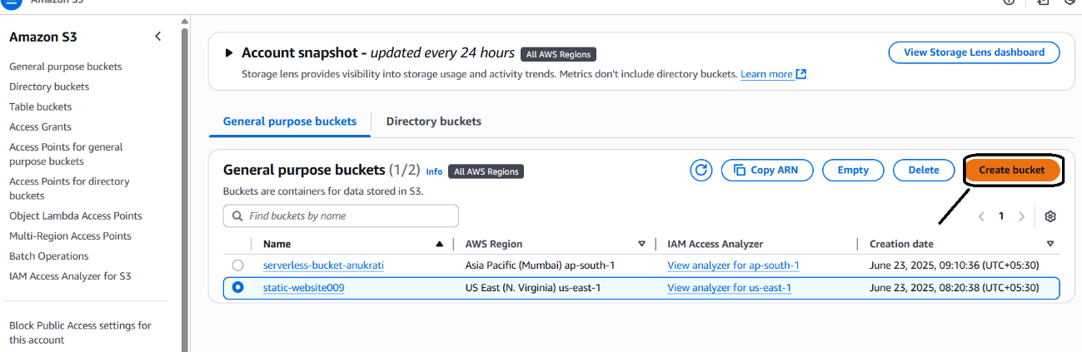

* Name it (must be globally unique)
* We have to enable the ACL.

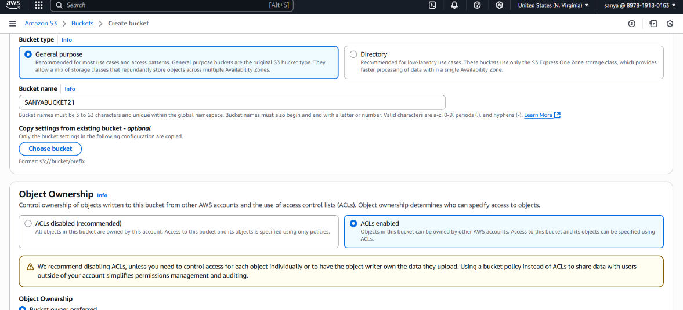

* Uncheck **Block all public access**
* Click on **Create bucket**.

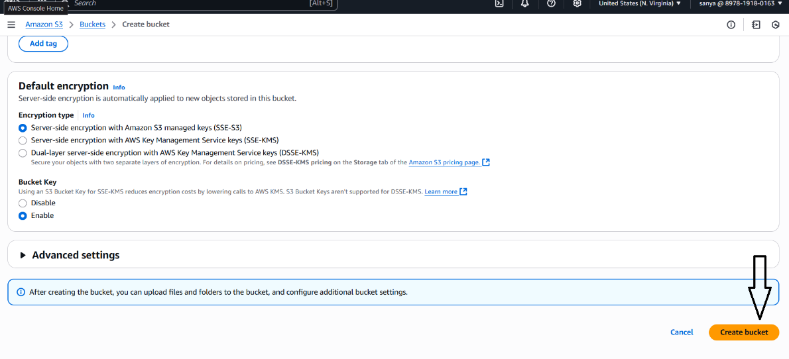

**5.2 Upload Website Files**

* Upload your static files (index.html, etc.) via the S3 console

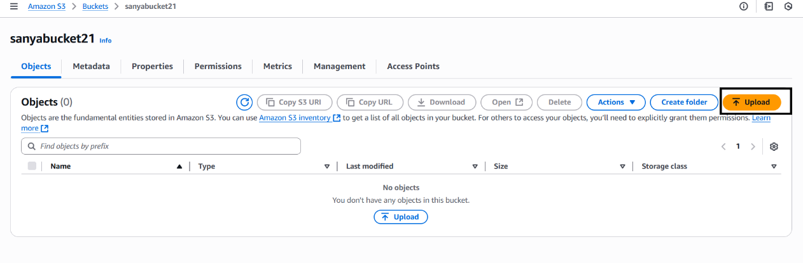

* Upload the files successfully.

**5.3 Enable Static Website Hosting**

* In the **Properties** tab

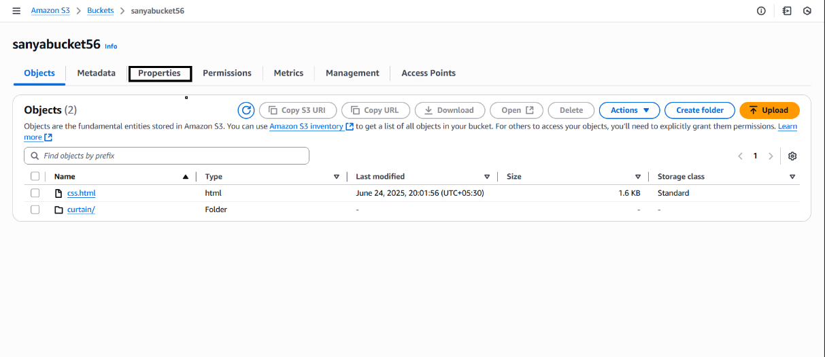

* Enable "Static Website Hosting"

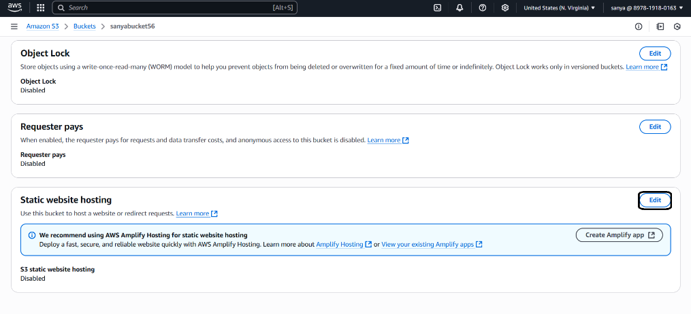

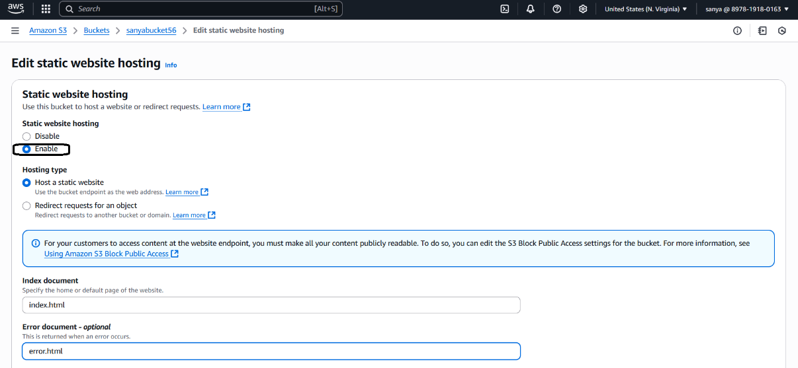

* . In s3 bucket go to actions and choose make public using ACL

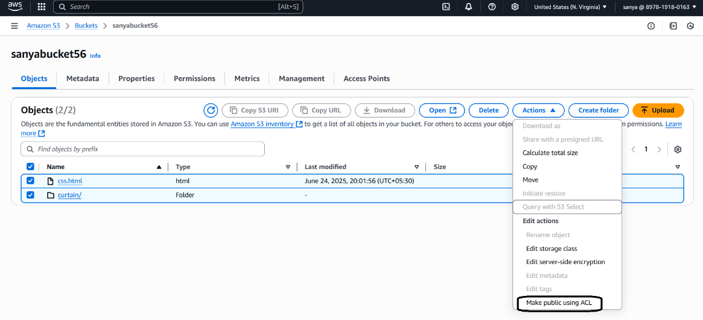.

* now copy the url of your uploaded file.

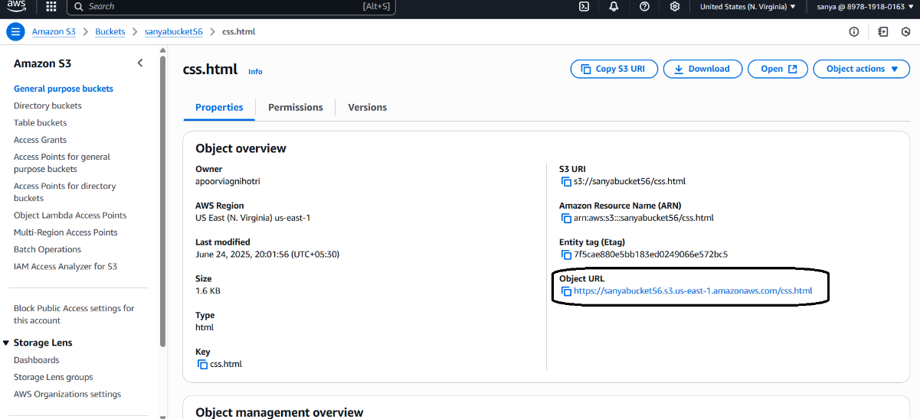

* Paste it in a browser

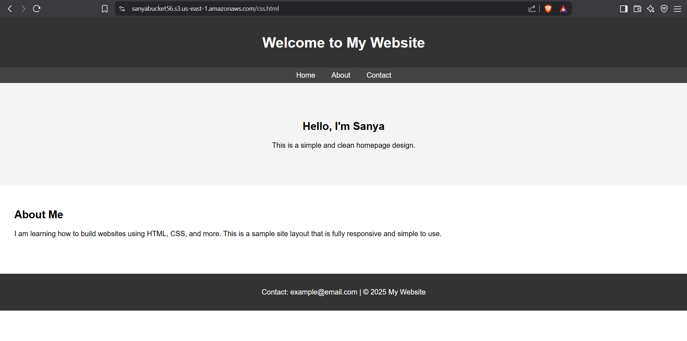

. then you will see the website.

**6. 🌐 Optional Enhancements**

**✅ Use a Custom Domain (Route 53)**

* Register/manage DNS with **Amazon Route 53**
* Point your domain to your S3 endpoint

**✅ Add HTTPS with Amazon CloudFront & ACM**

* Create a CloudFront distribution with your S3 as origin
* Request an SSL certificate via **AWS Certificate Manager**
* Connect domain to CloudFront via Route 53

**7. 🏁 Conclusion**

Hosting a static website on AWS is:

* Fast to set up
* Very cost-effective
* Scalable and reliable